**VISVESVARAYA TECHNOLOGICAL UNIVERSITY BELGAVI - 590018**



A Mini project report on

**“ARDUINO BASED ROBOTIC ARM**

**(PIC AND PLACE ROBOT)”**

BY

PRAJVAL BADIGER

(USN: 4UB16EC029)

AND

ERANNA S. NAVALAGUNDA

(USN: 4UB16EC008)

UNDER THE GUIDANCE OF:

Mrs. GEETHA V

Prof, Dept. of Electronics and Communication



2017-2018

DEPARTMENT OF ELECTRONICS AND COMMUNICATION ENGINEERING

UBDT COLLEGE OF ENGINEERING, DAVANGERE-577004

**UBDT COLLEGE OF ENGINEERING**

**DEPARTMENT OF ELECTRONICS AND COMMUNICATION**



**CERTIFICATE**

This is to certify that Mini Project entitled “**ARDUINO BASED ROBOTIC ARM”** is a bonafide record of the Mini Project done by **PRAJVAL BADIGER** bearing **USN: 4UB16EC029** under our guidance and supervision at the Department of Electronics and Communication Engineering, UBDT college of Engineering, Davangere, has completed the Mini project in the Fourth semester of Visveswaraya Technological University, Belagavi during the academic year 2017-2018.

---------------------------------------- ----------------------------------------

Project guide Head of the department

Mrs. GEETHA V Dr. MANJANAIK  
 Senior Professor Professor

ACKNOWLEDGEMENT

I would like to thank all those who helped us to make this Mini Project a successful one.

First my special thanks to our guide Mrs. **Geetha V**, Senior Professor, Department of Electronics and Communication Engineering who guided to understand the topic and gave suggestions on improvement of this Mini Project and also for providing resources for the completion of this Mini project for her co-operation and encouragement at all of our approach.

I would like to thank Dr. Manjanaik HOD of Electronics and Communication, for providing us an platform for conducting this Mini Project.

Place: Davangere PRAJVAL BADIGER

Date: 26-5-2018 (4UB16EC029)

ABSTRACT

A **Robotic Arm** is a type of [mechanical arm](https://en.wikipedia.org/wiki/Mechanical_arm), usually [programmable](https://en.wikipedia.org/wiki/Program_(machine)), with similar functions to a human [arm](https://en.wikipedia.org/wiki/Arm); the arm may be the sum total of the mechanism or may be part of a more complex [robot](https://en.wikipedia.org/wiki/Robot). The links of such a manipulator are connected by joints allowing either rotational motion (such as in an [articulated robot](https://en.wikipedia.org/wiki/Articulated_robot)) or translational (linear) displacement.The links of the manipulator can be considered to form a [kinematic chain](https://en.wikipedia.org/wiki/Kinematic_chain). The terminus of the kinematic chain of the manipulator is called the [end effector](https://en.wikipedia.org/wiki/End_effector) and it is analogous to the human [hand](https://en.wikipedia.org/wiki/Hand)

The end effector, or robotic hand, can be designed to perform any desired task such as welding, gripping, spinning etc., depending on the application. For example, robot arms in [automotive](https://en.wikipedia.org/wiki/Automotive) [assembly lines](https://en.wikipedia.org/wiki/Assembly_line) perform a variety of tasks such as [welding](https://en.wikipedia.org/wiki/Welding) and parts rotation and placement during assembly. In some circumstances, close emulation of the human hand is desired, as in robots designed to conduct [bomb disarmament and disposal](https://en.wikipedia.org/wiki/Bomb_disposal).

In our case the Robotic Arm is going to pick and place any object from on palace to other within its radius.

CONTENTS

CHAPTER PAGE NO.

1. INTRODUCTION 6
2. CIRCUIT AND WORKING 8
3. SOFTWARE PROGRAMMES 10
4. CONSTRUCTION 14
5. PARTS LIST 15
6. CONCLUSION 16
7. REFERENCES 16

CHAPTER 1

**INTRODUCTION**

An Arduino based Robotic arm is a robot which use micro servo motors for its operation and these motors and controlled by Arduino Uno. Let’s start knowing about the individual parts of the Robot.

**1.Micro Servo Motors:**

It is tiny and lightweight with high output power. This servo can rotate approximately 180 degrees (90 in each direction), and works just like the standard kinds but smaller. You can use any servo code, hardware or library to control these servos. It comes with a 3 horns (arms) and hardware.

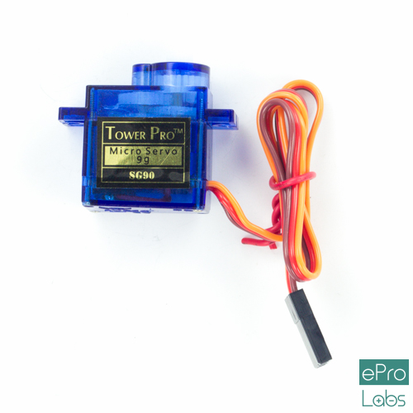

**Specifications**

* Operating voltage: 4.8 V (~5V)
* Operating speed: 0.1 s/60 degree
* Stall torque: 1.8 kgf·cm
* Dead band width: 10 µs
* Temperature range: 0 ºC – 55 ºC

**How to connect SG90 micro servo motor to Arduino Uno?**

**Hardware and Software Required**

* SG90 Micro Servo motor
* Arudino Uno
* Arduino IDE(1.0.6V)
* **Hardware connections**
* The SG90 micro servo motor has 3 wire interface in which the connections are made as follows:
* Red wire-5V
* Brown wire-Ground
* Yellow wire-digital pin 9

**2. Potentiometer :**

A potentiometer is a three-[terminal](https://en.wikipedia.org/wiki/Terminal_(electronics)) [resistor](https://en.wikipedia.org/wiki/Resistor) with a sliding or rotating contact that forms an adjustable [voltage divider](https://en.wikipedia.org/wiki/Voltage_divider). If only two terminals are used, one end and the wiper, it acts as a *variable resistor* or [*rheostat*](https://en.wikipedia.org/wiki/Potentiometer#Rheostat).

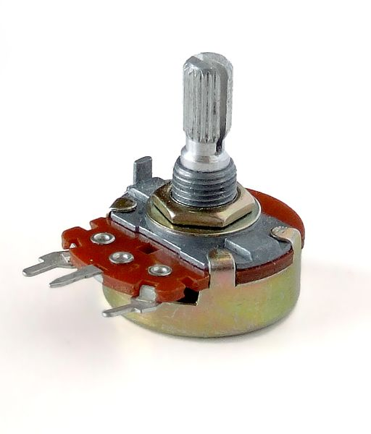

The measuring instrument called a [potentiometer](https://en.wikipedia.org/wiki/Potentiometer_(measuring_instrument)) is essentially a [voltage divider](https://en.wikipedia.org/wiki/Voltage_divider) used for measuring [electric potential](https://en.wikipedia.org/wiki/Electric_potential) (voltage); the component is an implementation of the same principle, hence its name.

Potentiometers are commonly used to control electrical devices such as volume controls on audio equipment. Potentiometers operated by a mechanism can be used as position [transducers](https://en.wikipedia.org/wiki/Transducer), hence we can we potentiometer to control the position of the Robotic Arm.

**3. Ardiuno Uno:**

The Arduino Uno is the most common version of Arduino family. The Arduino Uno is a micro controller board based on the ATmega328.It has 14 digital input/output pins (of which 6 can be used as PWM outputs), 6 analog inputs, a 16 MHz ceramic resonator, a USB connection, a power jack, an ICSP header, and a reset button. The Arduino Uno is great choice for beginners. It contains everything needed to support the micro controller; simply connect it to a computer with a USB cable or power it with an AC-to-DC adapter or battery to get started. The Arduino Uno is a good choice for beginners since it is easy to start with.

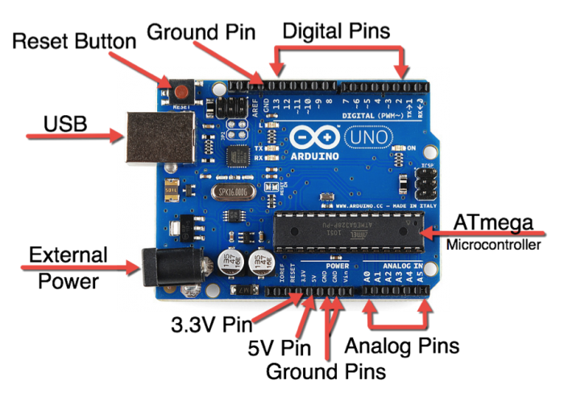

## Technical Specifications

1. **Microcontroller**- ATmega328
2. **Operating Voltage**- 5V
3. **Input Voltage (recommended)** - 7to12V
4. **Input Voltage(limit)** - 6to20V
5. **Digital I/O Pins**-14 (of which 6 provide PWM output)
6. **Analog Input Pins**-6
7. **DC Current per I/O Pin**-40 mA
8. **DC Current for 3.3V Pin**-50 mA
9. **Flash Memory**-32 KB (ATmega328) of which 0.5 KB used by boot loader
10. **SRAM**-2 KB (ATmega328)
11. **EEPROM**-1 KB (ATmega328)
12. **Clock Speed**-16 MHz

**CHAPTER 2**

**CIRCUIT AND WORKING**

6

9

10

11

10

This robotic arm is made up done of three segment joined by 3 joints

The Ardiuno controls the robot by rotating individual **Servo motors** connected to each joint. Unlike dc motors, servo motors can be controlled with precise angles from 0 to 180 degrees . The angle of the servo motors are controlled with the help of potentiometer.

Potentiometers provide analog input to the ardiuno. These analog inputs and maped to angle of the servo motor hence the motors can be controlled using Arduino and potentiometers.Each joint of the Robotic Arm consist of a servo motor and movement of the arm are due to the angle change in the servo motor. The end effector is also controlled by potentiometer and can be changed for different applications

**CHAPTER 3**

**SOFTWARE PROGRAMMES**

The code for the project is written in Ardiuno IDE .Following is the program implemented for the Robotic Arm.

#include<Servo.h>

Servo servo0, servo1, servo2, servo3;

int analogout[4] = {0, 0, 0, 0};

int pin_button = 12;

int pin_button_state = 0;

int last_pin_button_state = 0;

int stor0[200];

int stor1[200];

int stor2[200];

int stor3[200];

int recording;

int sensorVal[4];

int storage_loc;

void setup()

{

servo0.attach(10);

servo1.attach(11);

servo2.attach(9);

servo3.attach(6);

pinMode(pin_button, INPUT);

pinMode(A0, INPUT);

pinMode(A1, INPUT);

pinMode(A2, INPUT);

pinMode(A3, INPUT);

}

void loop() // main loop

{

button();

mapval();

writeval();

record();

play();

}

void button() {

pin_button_state = digitalRead(pin_button);

if (pin_button_state != last_pin_button_state) {

if (pin_button_state == HIGH) {

delay(100);

recording++;

}

delay(50);

}

}

void mapval() {

if (recording == 0) {

sensorVal[0] = analogRead(A0);

sensorVal[1] = analogRead(A1);

sensorVal[2] = analogRead(A2);

sensorVal[3] = analogRead(A3);

analogout[0] = map(sensorVal[0], 0, 1023, 0, 180);

analogout[1] = map(sensorVal[1], 0, 1023, 0, 180);

analogout[2] = map(sensorVal[2], 0, 1023, 0, 180);

analogout[3] = map(sensorVal[3], 0, 1023, 0, 180);

}

}

void writeval() {

servo0.write(analogout[0]);

servo1.write(analogout[1]);

servo2.write(analogout[2]);

servo3.write(analogout[3]);

}

void record() {

if (recording == 1) {

sensorVal[0] = analogRead(A0);

sensorVal[1] = analogRead(A1);

sensorVal[2] = analogRead(A2);

sensorVal[3] = analogRead(A3);

analogout[0] = map(sensorVal[0], 0, 1023, 0, 180);

analogout[1] = map(sensorVal[1], 0, 1023, 0, 180);

analogout[2] = map(sensorVal[2], 0, 1023, 0, 180);

analogout[3] = map(sensorVal[3], 0, 1023, 0, 180);

writeval();

if (storage_loc < 180) {

stor0[storage_loc] = analogout[0];

stor1[storage_loc] = analogout[1];

stor2[storage_loc] = analogout[2];

stor3[storage_loc] = analogout[3];

delay(50);

storage_loc++;

}

}

}

void play() {

if (recording > 1) {

while (true) {

for (int i = 0; i < storage_loc; i++) {

servo0.write(stor0[i]);

servo1.write(stor1[i]);

servo2.write(stor2[i]);

servo3.write(stor3[i]);

delay(50);

}

}

}

}

***code ends***

**CHAPTER 4**

**CONSTRUCTION**

The whole body of the arm is made up of light weight wood making it eaiser to light weigth. Light weight wood is used since the servo motors have low torque and can’t handle more weight.

The wood is cut in proper dimensions for each segment and then groves are made in appropriate positions to fit servo motors in it.

The end effector is made of a zip tie and is fixed at the end of the top most segment. The end effector is such that it can hold any object, mimicking the hand hold gesture of humans.

The base is also made of wood on which the arm is mounted.

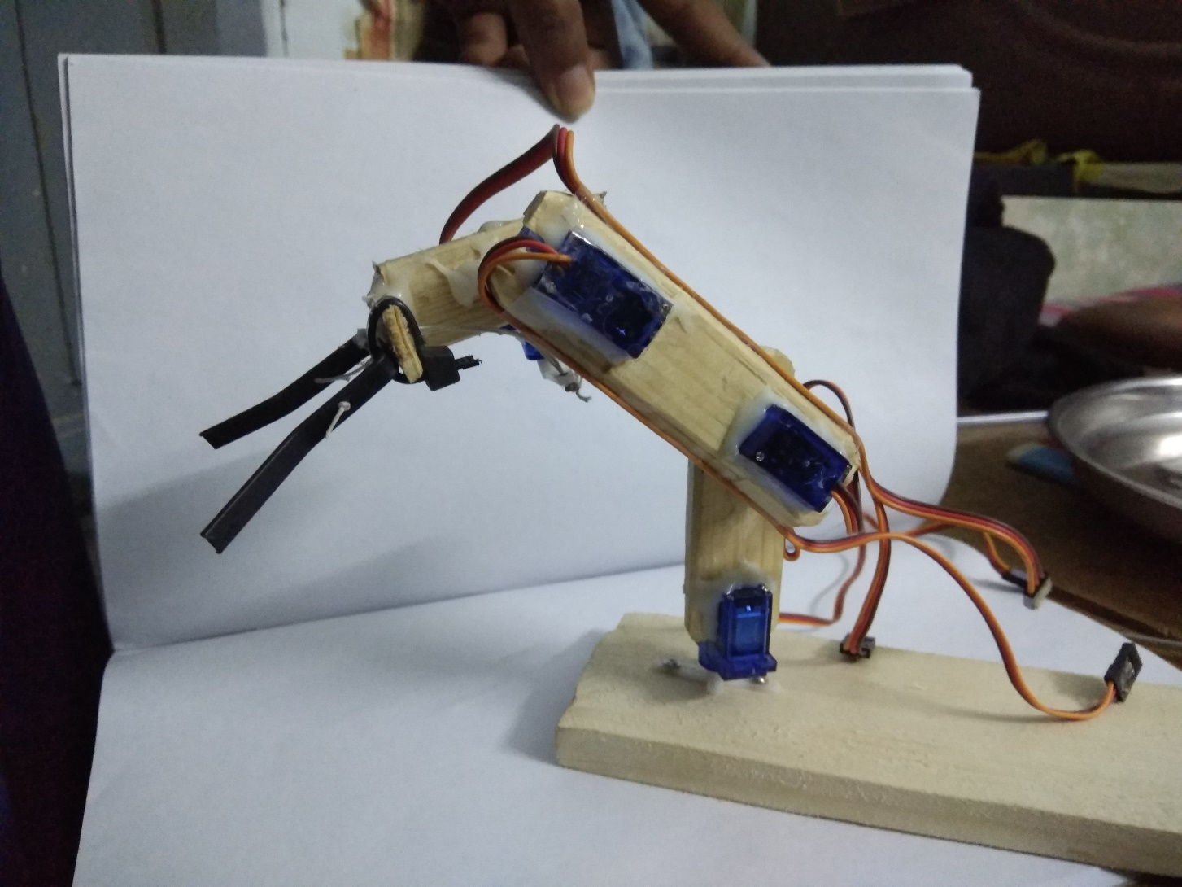

**CHAPTER 5**

**PARTS LIST**

1. Micro Servo motors SG90 - 4 no’s
2. ARDUINO UNO - 1 no’s
3. Potentiometers 10k - 4 no’s
4. Battery 4.8v - 1 no’s
5. Breadboard - 1 no’s
6. Push button - 2 no’s
7. Resistors 10k ohms - 1 no’s
8. Connecting wires --

**CONCLUSION**

The [International Federation of Robotics](https://en.wikipedia.org/wiki/International_Federation_of_Robotics) has predicted a worldwide increase in adoption of industrial robots and they estimated 1.7 million new robot installations in factories worldwide by 2020.Now a days robotic arms are used almost everywhere from industries to space robots . Due to its efficiency and accuracy robotic arms are the most commonly used robot in automobile industries to paint, to tighten screws etc. The end effector can be changed for each task such as , a robotic arm that paints would have a paint spray its end effector.

Reference:

<https://en.wikipedia.org/wiki/Robotic_arm>

<https://www.robotshop.com/letsmakerobots/micro-servo-robot>